Use subqueries to answer the following questions:

1. Has our organization sales grown over the years?

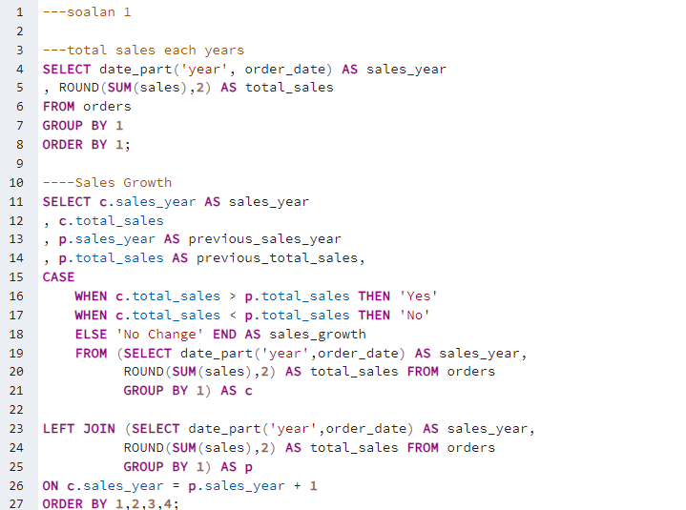

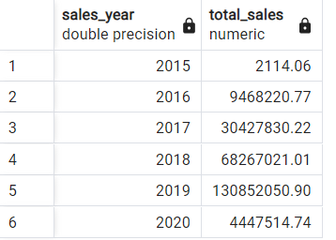

---soalan 1

---total sales each years

SELECT date_part('year', order_date) AS sales_year

, ROUND(SUM(sales),2) AS total_sales

FROM orders

GROUP BY 1

ORDER BY 1;

----Sales Growth

SELECT c.sales_year AS sales_year

, c.total_sales

, p.sales_year AS previous_sales_year

, p.total_sales AS previous_total_sales,

CASE

WHEN c.total_sales > p.total_sales THEN 'Yes'

WHEN c.total_sales < p.total_sales THEN 'No'

ELSE 'No Change' END AS sales_growth

FROM (SELECT date_part('year',order_date) AS sales_year,

ROUND(SUM(sales),2) AS total_sales FROM orders

GROUP BY 1) AS c

LEFT JOIN (SELECT date_part('year',order_date) AS sales_year,

ROUND(SUM(sales),2) AS total_sales FROM orders

GROUP BY 1) AS p

ON c.sales_year = p.sales_year + 1

ORDER BY 1,2,3,4;

1. On average, what percent of salespeople make a sale each month?

---soalan 2

-- Total sales

SELECT SUM(sales) AS total_sales

FROM orders;

-- Monthly sales

select date_trunc('month', order_date) AS order_month, SUM(sales) AS monthly_sales

FROM orders

GROUP BY 1;

-- Percentage monthly sales

SELECT date_trunc ('month', order_date) AS order_month,

ROUND ((SUM (sales) /(SELECT SUM(sales) AS total_sales FROM orders))*100, 2) AS percentage_monthly_sales

FROM orders

GROUP BY 1;

-- Average percent of salespeople make a sale each month

SELECT date_part ('month', pms.order_month) AS month,

AVG (percentage_monthly_sales) AS average_percentage_monthly_sales

FROM (

SELECT date_trunc ('month', order_date) AS order_month

, ROUND ((SUM(sales) /(SELECT SUM(sales) AS total_sales FROM orders)) *100, 2) AS percentage_monthly_sales

FROM orders GROUP BY 1) AS pms GROUP BY 1;

1. What percent of all sales in the United States did returns make up in 2020

